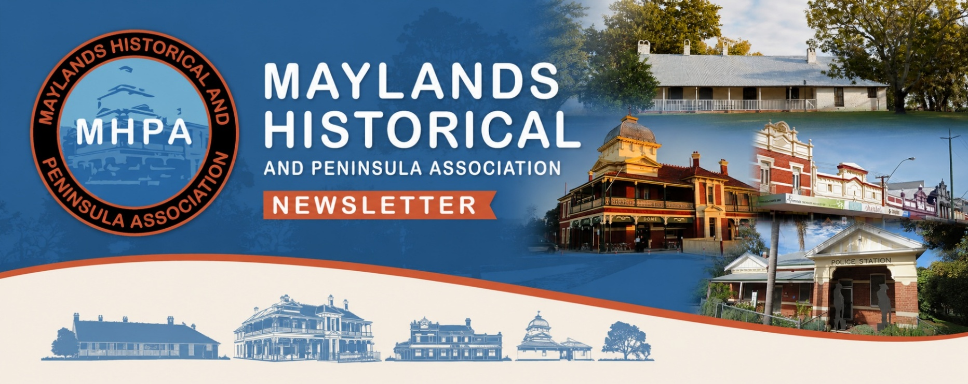

Walks
We offer four self-guided walking tours that bring the suburb’s past to life. Each walk can be completed in one to two hours, and all are accessible by public transport.
Go to the Walks Page on our website for further details or pop into the Old Police Station and pick up one of the walk cards.
Interactive Map
Use the Interactive Map to discover and learn about the many interesting places, people and buildings that exist in this fascinating suburb we call Maylands.
Go to the Interactive Map Page on our website for further details or see the map in action at the Old Police Station.

July 2026
Our Resources
If you want to learn more about the history of our unique suburb we hold an interesting collection of reference books, articles, documents, photos, audio recordings, videos and memorabilia at the Old Police Station and on our website.
We welcome visitors and researchers who would like to visit our premises and talk to us about their interests.
We are open most Wednesdays from 9.30am to 3pm and occasional Saturdays from 10am to 2pm. Our opening hours are regularly updated on our website Events Page.

Dear Members and Friends
I was very pleased by the positive reaction to the first issue of this new-design newsletter. I hope that you find the latest edition equally interesting and engaging as we summarise another successful month of activity and share some snippets of local information that we hope will educate, inform and amuse 😊
As always, we hope to see you at one of our upcoming talks, or at the Old Police Station. Any feedback on the Newsletter, or suggestions for future issues, would also be welcome.
Best Wishes
Keith Cundale
President, MHPA
100 Years Ago?
Severe Flooding of Swan River
Did you know 100 years ago, in July 1926, severe and widespread flooding in the Avon, Swan and Helena River districts caused the Fremantle railway bridge and Upper Swan bridge to collapse. Continued over the page.
The river burst its banks at Barrack St submerging jetties and bursting into offices. Flood waters rose along the foreshore by more than 137m.
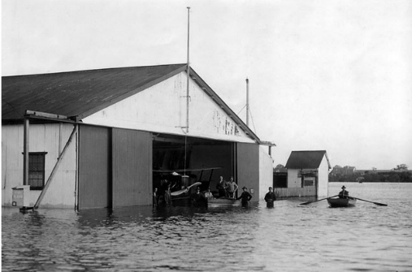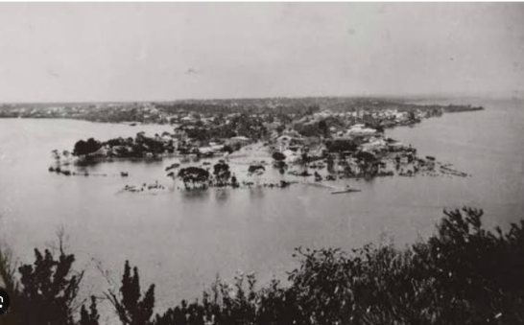
South Perth Foreshore
Airline hangar Maylands
aerodrome
Monthly public talks
One of our most popular ways of engaging with the local community is through the public talks we offer each month in the dining room of the Old Peninsula Hotel (Dome Cafe) on Railway Parade, Maylands. We aim to offer a wide variety of talks covering many different aspects of the heritage and history of Maylands as well as further afield. Talks are given by our own members and guest speakers and are held on the 3rd Monday of each month. Talks start at 7.15 for 7.30pm, no booking is usually necessary and entry is always free! Newcomers, friends and neighbours are always made welcome if they chose to come along to these informal and entertaining evenings.

One of our most popular ways of engaging with the local communities is through the public talks we offer each month in the dining room of the Old Peninsula Hotel (attached to the Dome coffee building) on Railway Parade, Maylands. We aim to offer a wide variety of talks covering many different aspects of the heritage and history of Maylands as well as further afield. Talks are given by our own members and guest speakers and are held on the 3rd Monday of each month. Talks start at 7.15 for 7.30pm. No booking is usually necessary and entry is always free! Newcomers, friends and neighbours are always made welcome if they chose to come along to these informal and entertaining evenings.

In South Perth, 14 houses were inundated between Scott St and Mill Point. Waves surged along Mill Point Rd and residents sailed a yacht up suburban streets, according to newspaper reports at the time.
Market gardens along the river at Mounts Bay Road, and in Belmont and Maylands, were flooded by over a metre. Meanwhile, floodwaters spread over 5km of Guildford, with houses in South Guildford submerged up to their roofs. Despite extensive reports of damage, the waters did not reach the height of the 1862 floods. Over 12 million litres of water cascaded over Mundaring Weir.
Miss Australia Flies into Maylands
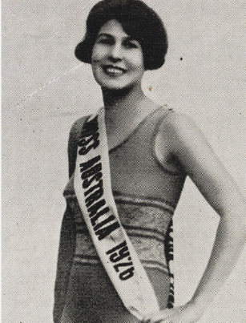
Also 100 years ago, in mid-July 1926, Australia’s first Miss Australia, Beryl Mills, famously flew from Geraldton, where she had been visiting her grandmother, to Perth's Maylands Aerodrome aboard a chartered four-seater aircraft. The flight made headlines as she was whisked back to Perth for a series of civic receptions which included meeting the governor at Government House, and to catch a theatrical performance.
Following this whirlwind trip to Perth, she returned to Geraldton before embarking on an international promotional tour in America.

Looking back at recent activities
Our speaker in June was Deb Huff who talked about the background to her new book: “Gossip, ghosts and good times: Perth’s most colourful building histories”.
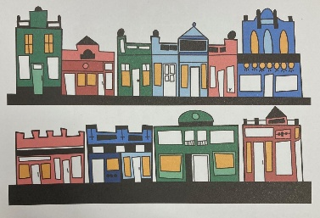
A large audience was interested to learn of how she first settled in Maylands, living above “Smoults Larder” and getting to know the owners of the local businesses along Whatley Crescent.
Audience at Deb’s talk
The Old Peninsula Hotel
Parade of shops along Whatley Crescent
Deb started sketching these distinctive buildings, and over the years since, has developed a unique style that she now employs to illustrate the stories behind the buildings and the people who live and work in them. Two images of Maylands are shown above. We have a copy of her book in the Old Police Station if you would like to browse through it when you visit us.

Looking ahead
July 20th – Story of Stained Glass in WA

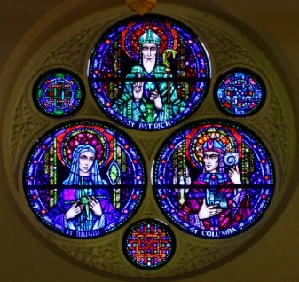
Dr Fiona Bush OAM is a recognised archaeologist and heritage consultant as well as an active member of the Council of History West and many different community groups in her neighbourhood of Mundaring. Fiona will give an illustrated talk about the rich and beautiful history of stained glass as she recounts the evolution of artistic skills as well as glass-making techniques which together created the many different styles of stained glass to be found around WA.
The schedule of future talks is regularly updated on our website.

Behind the Scenes at MHPA
A lot of work is going on at Maylands Historical that is ‘behind the scenes’ and which contributes to the effectiveness and impact of our resources: pictures, personal stories and documents of all kinds. The long-term “Digitisation” project is going really well and we have probably had about half of the initial set of documents professionally scanned. These will form the basis of a comprehensive database that can be searched and explored on-line. Of course, we will be keeping the original documents, and they will always be available for anyone undertaking research. Thank you to Gertie, Val and Bobbie for their continuing hard work together in the “back office” at the Old Police Station.
Charlie Pitt, a new volunteer, is working with us to reorganise and catalogue the books in our library and the plan is to set up a more customer-friendly book-nook and reading area in the main room at the Old Police Station. Another new volunteer, Dolly Pang, is helping us upload information from the City of Bayswater Listing of Heritage Buildings onto the website to be accessed through the digital map. Thank you to all of our backroom staff and volunteers.
Talking of the digital map, we are constantly adding new information to it and it is certainly worth taking a look. To date we have had over 25,000 views from around the world!
Our Sponsors
As a voluntary community organisation we rely on the generous support of our sponsors to help us fulfil our Mission.
We encourage you to support these organisations.





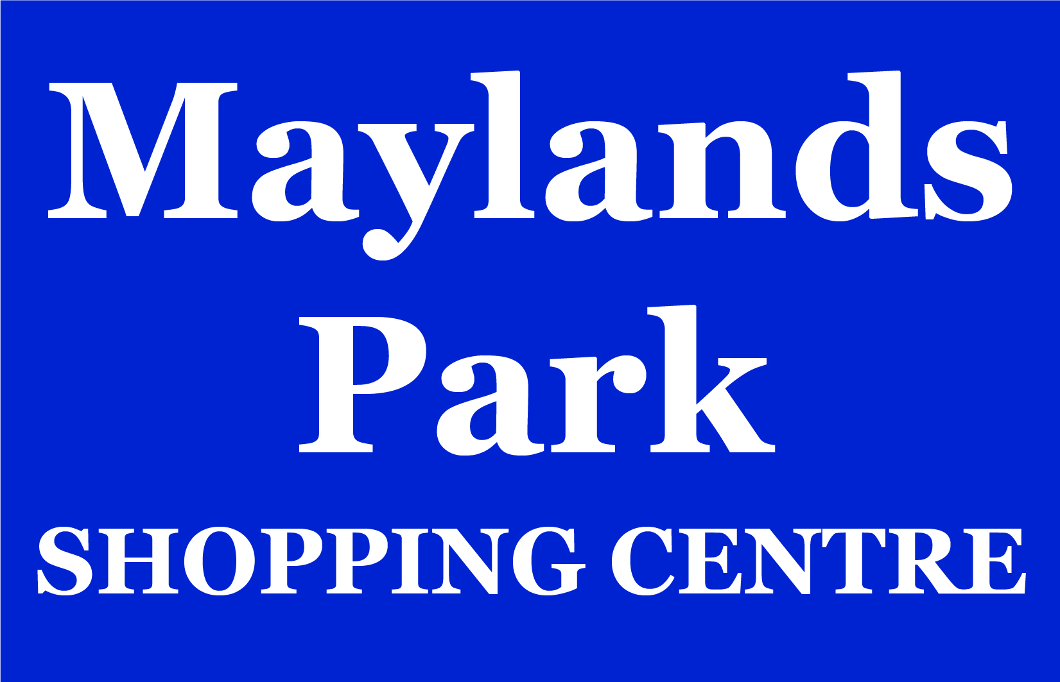


Lyric Lane






Ways That You Can Help Us
- Attend upcoming events

- Help us with specific projects that match your interests and skills. Contact us to chat about this.

- Share local history and memories

- Become a member

- Donate or sponsor a project

Join us
Go to https://maylandshistorical.com.au/membership-application/ or click on button below


Sign up to our Newsletter
Go to https://maylandshistorical.com.au/newsletter-sign-up-form/ or click on button below


